**Part 1: Setting it up first time:**

-Install git (Bits you need to type are colour in red. Don’t include “ ”)

**sudo apt-get install git  (it may already be installed)**

**git config --global user.name "username"**

**git config --global user.email "**[**your_email@example.com**](mailto:your_email@example.com)**"**

-Make a folder that will sync up with github. Maybe name it after your group.

**mkdir “name of folder”**

*eg. mkdir gitalpha*

-Open that folder (change the directory “cd” to the new folder)

**cd “name of that folder you just made”**

*eg. cd gitalpha*

-Add invisible git files to the folder so that GitHub can link to it

**git init**

-Tell your Pi where where to find your group’s repository online. Find the address of the git by opening it on github and clicking “Clone or download”. In yellow.

**git remote add origin https://github.com/”username”/”repo name”.git**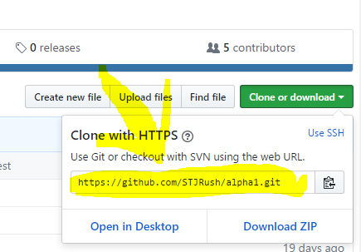

*eg. git remote add origin* [*https://github.com/STJRush/rpi.git*](https://github.com/STJRush/rpi.git)

**Part 2: Everyday use (pushing and pulling)**

**How to move files from Github->Pi**

-Pull down the latest copy of the your files from Github onto your Raspberry Pi:

**git pull origin master**

**How to move files from Pi->Github**

-Add files to prepare a commit (a save)

**git add .**

-Commit changes with a -message. Do include the “” marks.

**git commit -m "my message to explain the change"**

***eg. git commit -m "fixed a bug with elif, else"***

-Push your changes up to the master branch on Github.

**git push origin master**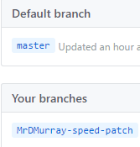

-You’ll be asked for your username and password to be sure that you have access to change the online repository.

-BONUS: You don’t have to use the master branch. All of the above can be done with your own branches.